Recursive

Index slicing：

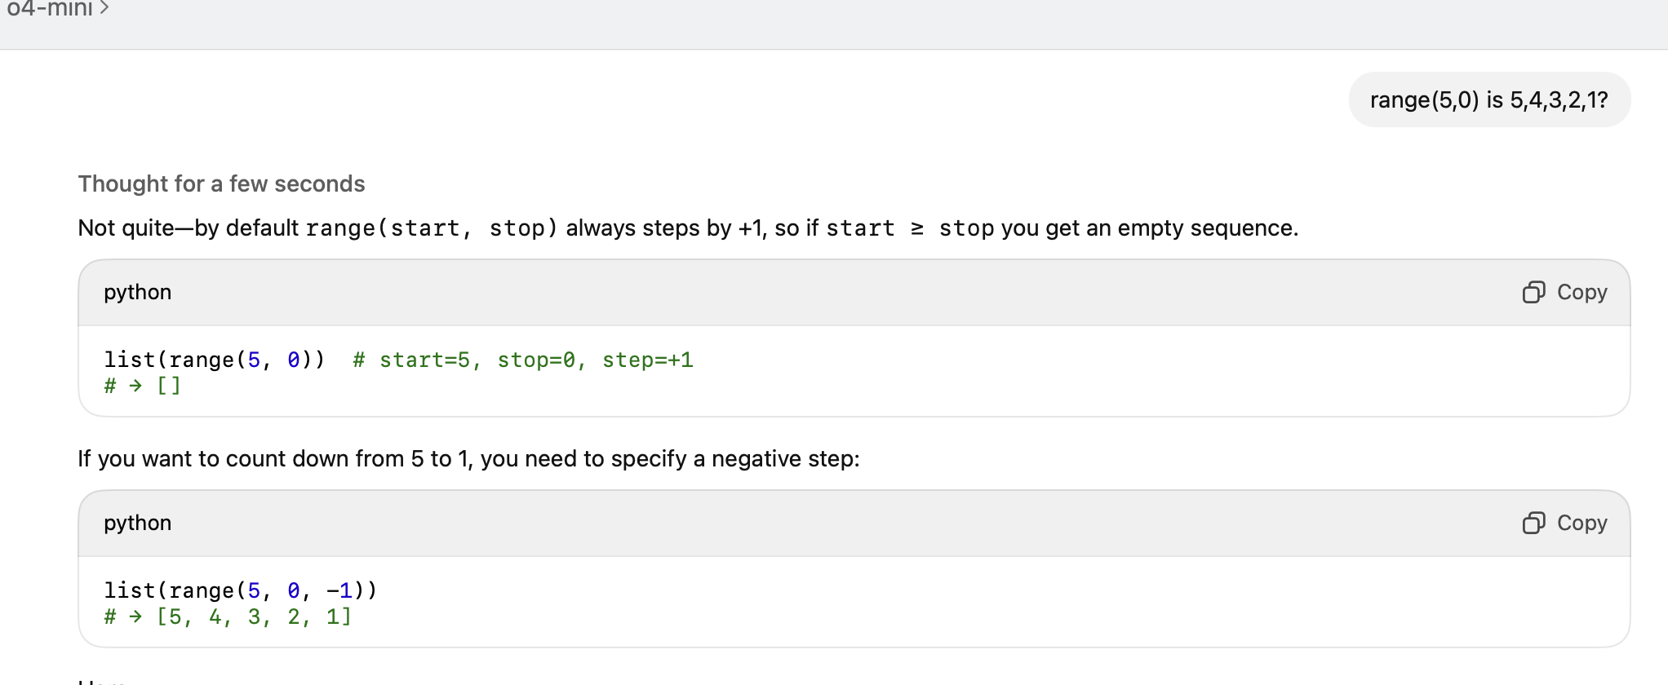

可以直接在string里面loop数char

Removing leading and trailing spaces

Removing Leading and Trailing Spaces 
Sometimes, we only need to remove spaces from the start and end of a string while leaving the inl 
spaces untouched. In such cases, stci2(). method is ideal. 
Hello World 
11 
# Remove any leading and trai ling whitespace from string 
s. strip() 
print(s) 
Output 
Hello World 
Explanation: s.strip() removes spaces from the start and end of s. 
Removing Leading Spaces Only 
If we only want to remove spaces from the beginning of the string, we can use Istri2().. 
Hello World" 
# Remove any leading whitespace from string 
s. Istrip() 
print(s) 

String with Special Characters v 
specla 
# Remove leading and trailing special characters 
string_slice 
string_slice. 1st rip( special) . rstrip( special) 
# Remove spaces (if needed) 
clean_string_slice 
string_slice. replace(" " ' 
print( lice) 
# The slicing syntax has an error. To get every 7th element in reverse order: 
result 
print( result) 
The issue with your last line lice [0: , —7] is that the slicingsyntaxis 
incorrect. In Python, slicing is done with the format [start: end : step] I. The 1—7 doesn't 
make sense as a second parameter with a comma. 
To slice every 7th element in reverse order: 
1. First reverse the string with [ : :-1] 
2. Then take every 7th character with [ : : 7] 
This approach will give you the characters at positions O, 7, 14, 21, etc. from the reversed 
string. 
Reply to Claude... 
3.7 Z Choose style v 
Copy 
O 

Strip,This removes extra whitespace and newline characters.

Just write out the 12 16 20 24….starting from 0

Unpacking unites list into a string, if no sep=¨¨ then there is a natural space in between.(exam 23 Task 2)

Random numbers,1-10, total 100 random nums

